Important!
[NL] Biweekly Coordination Meeting for Open Information Extraction (OIE) project https://kstate.atlassian.net/wiki/x/vYDq2g - Tue 09 Sep 2025
Log in with Atlassian account
Log in to Jira, Confluence, and all other Atlassian Cloud products here. Not an Atlassian user? Sign up for free.

Three domains
- Neuroscience
- Mental Health
- Climate Science

I do not have access to: https://github.com/orgs/kddresearch/projects/30
https://github.com/kddresearch/KDDIE

My GitHub: JamesChapmanNV (JamesChapmanNV@Gmail.com)

William Hsu
Three domains NeuroscienceMental HealthClimate Science
- https://www.k-state.edu/cnap/
- https://www.k-state.edu/cnap/projects-pilot-grants/projects.html
- https://www.k-state.edu/cnap/research-cores/
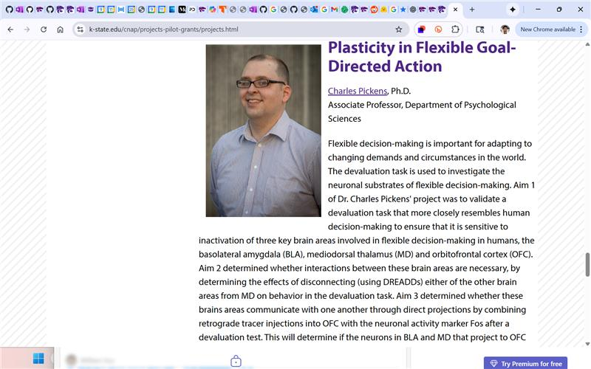
CNAP Research Cores

Cognitive and Neurobiological Approaches to Plasticity (CNAP) - an NIH COBRE
- CNAP Rat Behavior - https://kstate.atlassian.net/wiki/x/AgD84g (on hiatus, methods include vision transformers for tasks related to Ahsan's work)
  - https://www.k-state.edu/cnap/projects-pilot-grants/pilot-grants.html - Dr. Bethany Plakke Anderson
  - https://huggingface.co/docs/transformers/en/tasks/video_classification
  - Lead collaborator from CS: NI core lead, Dr. Doina Caragea (with Emily Alfs-Votipka )
- CNAP Astroglia - https://kstate.atlassian.net/wiki/x/AYD_4g
  - Dr. Meena Kumari - oxycodone toxicity in glial cells
  - Tracking deformable objects (cells) that are uniquely identifiable via repeated detection without registration
  - main collaborator - Dr. William H. Hsu, Yihong Theis
- CNAP Inverse RL from Rat Behavior Data
  - Dr. Maria Diehl Faryna (proposal 2023-13) - platform-mediated avoidance (PMA) in rats
  - Time-delay aspect
  - Socialization aspect (off-policy & possible actor-critic via learning by demonstration)
  - https://en.wikipedia.org/wiki/Imitation_learning
  - https://en.wikipedia.org/wiki/Apprenticeship_learning
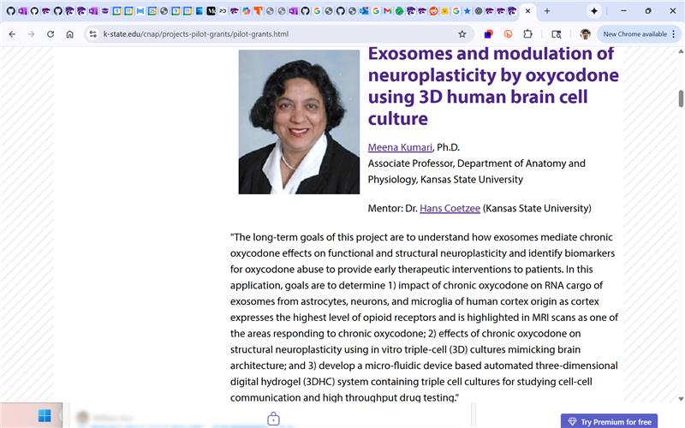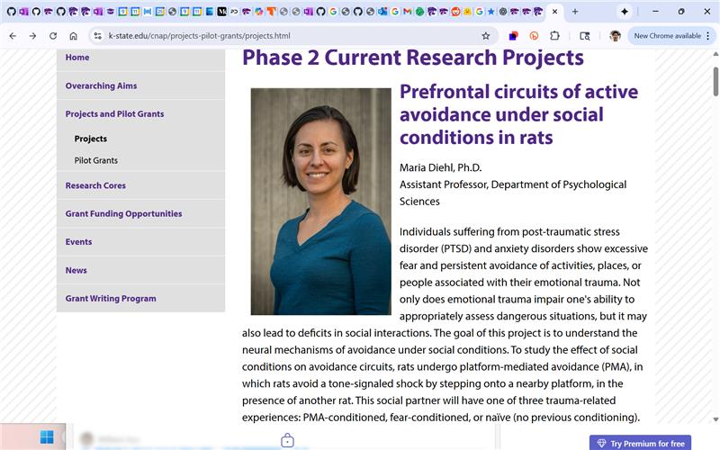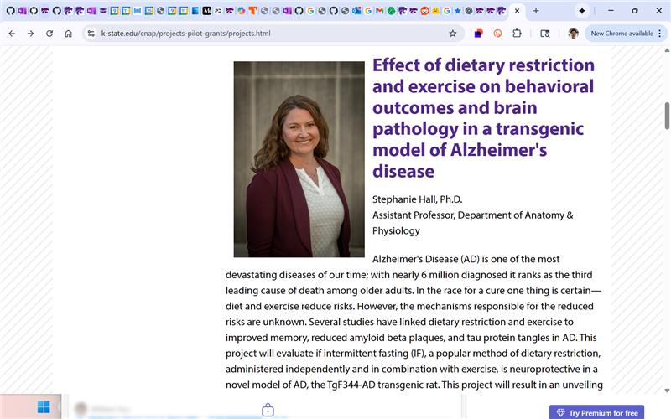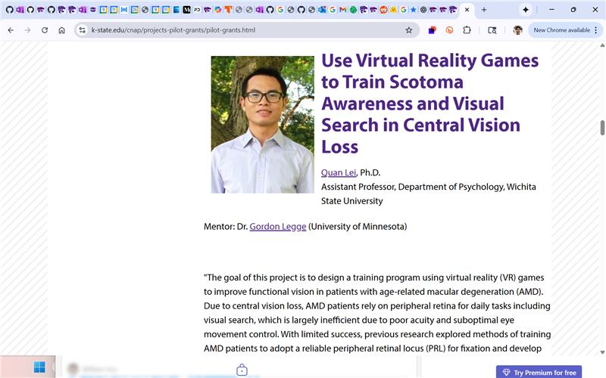
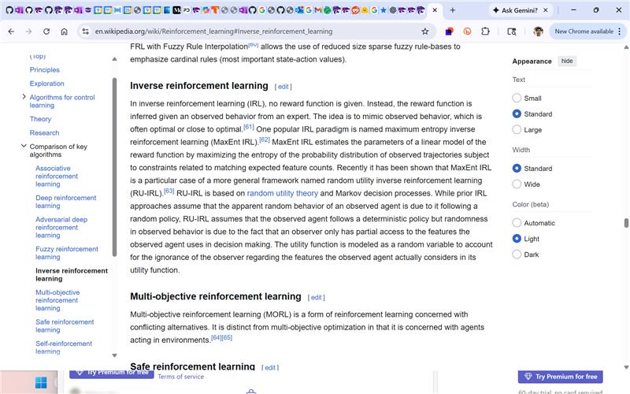
Log in to Jira, Confluence, and all other Atlassian Cloud products here. Not an Atlassian user? Sign up for free.

William Hsu
Cognitive and Neurobiological Approaches to Plasticity (CNAP) - an NIH COBRE CNAP Rat Behavior - https://kstate.atlassian.net/wiki/x/AgD84g (on hiatus, methods include vision transformers for tasks related to Ahsan's work) https://www.k-state.edu/cnap/projects-pilot-grants/pilot-grants.html -…
discovery informatics

Google AI Overview
Discovery informatics is a field that uses computation, data mining, and analytical technologies to uncover new information, patterns, and relationships within large, complex datasets, especially in the context of scientific discovery like drug development. Its core aim is to develop systems and tools that enable scientists to effectively extract insights from vast amounts of data, accelerating the process of identifying promising leads, understanding disease mechanisms, and making data-driven decisions in fields like medicine and pharmaceuticals. [1, 2, 3, 4, 5]

Key Aspects
- Data-Driven Insight: The primary goal is to discover new knowledge by identifying hidden trends, relationships, and anomalies in data that might not be obvious through manual analysis. [2, 6]
- Computational Tools: It leverages advanced computing, including machine learning, statistical modeling, and information theory, to analyze data. [7]
- Pattern Recognition: Employs techniques like data mining to automatically recognize underlying patterns and build predictive models. [2]
- Accessibility: Aims to create user-friendly systems where scientists can access and analyze data without requiring deep informatics expertise, similar to "surfing the web". [4]
- Collaboration: Facilitates better information sharing and collaboration among researchers, which is crucial for complex scientific breakthroughs. [5, 8]
Applications in Drug Discovery
- Lead Discovery: Helps identify and filter promising drug candidates from millions of chemical compounds. [5, 9]
- Target Identification: Assists in finding biological targets for new therapies by analyzing large datasets of biological and clinical information. [10, 11, 12]
- Preclinical Testing: Supports the evaluation of potential drugs by virtually screening molecules and predicting their interactions. [9, 10, 13, 14]
- Clinical Data Management: Creates systems to efficiently manage and analyze the enormous datasets generated during clinical trials. [1]
Why It Matters
- Accelerated Discovery: By streamlining data analysis and insight generation, discovery informatics helps to bring new drugs and therapies to market faster. [5]
- Improved Efficiency: It enables researchers to identify fruitful paths and avoid dead ends more quickly, reducing the time and resources spent on less promising avenues. [5]
- Precision Medicine: Supports the development of personalized treatments by analyzing individual patient data to tailor therapies to specific needs. [1]

AI responses may include mistakes.
[1] https://www.usfhealthonline.com/resources/health-informatics/drug-discovery-informatics-set-to-grow…
[2] https://cacm.acm.org/opinion/discovery-informatics/
[3] https://www.universityofgalway.ie/dsi/data_visualisation_simulation_discovery_informatics
[4] https://www.collaborativedrug.com/cdd-blog/drug-discovery-informatics-for-big-pharma-key-webinar-in…
[5] https://www.nature.com/articles/d42473-021-00323-z
[6] https://www.microsoft.com/en-us/security/business/security-101/what-is-data-discovery
[7] https://mbs.rutgers.edu/taxonomy/term/5251
[8] https://www.collaborativedrug.com/drug-discovery-informatics-for-big-pharma
[9] https://www.stjude.org/research/departments/chemical-biology-therapeutics/lead-discovery-informatic…
[10] https://www.longdom.org/open-access/the-five-pillars-of-drug-discovery-advancing-healthcare-through…
[11] https://lifebit.ai/blog/ai-drug-discovery-platform/
[12] https://www.drugpatentwatch.com/blog/ai-driven-drug-discovery-transforming-the-landscape-of-pharmac…
[13] https://seekingalpha.com/article/4743807-recursion-transforming-drug-discovery-with-its-ai-powered-…
[14] https://www.biorxiv.org/content/10.1101/2023.08.17.552618v1.full-text

Not all images can be exported from Search.

Just as informatics can help organize a medical records, discovery informatics make researching and creating effective new drugs faster and more efficient.

William Hsu
discovery informatics Google AI Overview Discovery informatics is a field that uses computation, data mining, and analytical technologies to uncover new information, patterns, and relationships within large, complex datasets, especially in the context of scientific discovery like drug develo…
https://www.kddresearch.org/page/publications
KSU KDD Wiki

William Hsu
https://www.kddresearch.org/page/publications
https://www.kddresearch.org/page/publications-conference

William Hsu
https://www.kddresearch.org/page/publications-conference
Hsu, W. H., King, A. L., Paradesi, M., Pydimarri, T., & Weninger, T. (2006). Collaborative and Structural Recommendation of Friends using Weblog-based Social Network Analysis. Computational Approaches to Analyzing Weblogs - Papers from the 2006 Spring Symposium, Nicolov, N., Salvetti, F., Liberman, M., & Martin, J. H., eds. pp. 24-31. AAAI Press Technical Report SS-06-03. Stanford, CA, USA, March 27-29, 2006.

William Hsu
Hsu, W. H., King, A. L., Paradesi, M., Pydimarri, T., & Weninger, T. (2006). Collaborative and Structural Recommendation of Friends using Weblog-based Social Network Analysis. Computational Approaches to Analyzing Weblogs - Papers from the 2006 Spring Symposium, Nicolov, N., Salvetti, F., Liberman,…
Hsu, W. H., Lancaster, J. P., Paradesi, M. S. R., & Weninger, T. (2007). Structural Link Analysis from User Profiles and Friends Networks: A Feature Construction Approach, Proceedings of the 1st International Conference on Weblogs and Social Media (ICWSM 2007), pp. 75-80. Boulder, CO, USA, March, 2007.

William Hsu
Hsu, W. H., Lancaster, J. P., Paradesi, M. S. R., & Weninger, T. (2007). Structural Link Analysis from User Profiles and Friends Networks: A Feature Construction Approach, Proceedings of the 1st International Conference on Weblogs and Social Media (ICWSM 2007), pp. 75-80. Boulder, CO, USA, March, 2…
Hsu, W. H., Weninger, T., & Paradesi, M. S. R. (2008). Predicting Links and Link Change in Friends Networks - Supervised Time Series Learning with Imbalanced Data, Proceedings of the 18th International Conference on Artificial Neural Networks in Engineering (ANNIE 2008). St. Louis, MO, USA, November 9-12, 2008.

William Hsu
Hsu, W. H., Weninger, T., & Paradesi, M. S. R. (2008). Predicting Links and Link Change in Friends Networks - Supervised Time Series Learning with Imbalanced Data, Proceedings of the 18th International Conference on Artificial Neural Networks in Engineering (ANNIE 2008). St. Louis, MO, USA, Novembe…
Aljandal, W., Hsu, W. H., Bahirwani, V., & Caragea, D. (2009) Ontology-Aware Classification and Association Rule Mining for Interest and Link prediction in Social Networks. Proceedings of the Association for the Advancement of Artificial Intelligence Spring Symposium on Social Semantic Web (AAAI SSW 2009), Stanford, CA, USA, March 23-25, 2009.

William Hsu
Aljandal, W., Hsu, W. H., Bahirwani, V., & Caragea, D. (2009) Ontology-Aware Classification and Association Rule Mining for Interest and Link prediction in Social Networks. Proceedings of the Association for the Advancement of Artificial Intelligence Spring Symposium on Social Semantic Web (AAAI SS…
Caragea, D., Bahirwani, V., Aljandal, W., & Hsu, W. H. (2009). Ontology-based link prediction in the LiveJournal social network. Proceedings of the 8th Symposium on Abstraction, Reformulation and Approximation (SARA 2009). Lake Arrowhead, CA, USA, July 7-10, 2009.

William Hsu
Caragea, D., Bahirwani, V., Aljandal, W., & Hsu, W. H. (2009). Ontology-based link prediction in the LiveJournal social network. Proceedings of the 8th Symposium on Abstraction, Reformulation and Approximation (SARA 2009). Lake Arrowhead, CA, USA, July 7-10, 2009.
Roy Chowdhury, S., Scoglio, C., & Hsu, W. H. (2010). Simulative modeling to control the foot and mouth disease epidemic. Proceedings of the International Conference on Computational Science (ICCS 2010) Workshop 27: Frontiers in the Computational Modeling of Disease Spreading. Procedia Computer Science, 2010(1), pp. 2261 - 2270. Amsterdam, The Netherlands, May 31 - June 2, 2010.

Elhamy, W., Caragea, D., & Hsu, W. (2010). KSU KDD: Word sense induction by clustering in topic space. Proceedings of the Association for Computational Linguistics 5th International Workshop on Semantic Evaluation, pp. 367–370. Uppsala, Sweden, July, 2010.
https://kdd.cs.ksu.edu/Publications/Conference/elshamy2010ksu.pdf

William Hsu
Roy Chowdhury, S., Scoglio, C., & Hsu, W. H. (2010). Simulative modeling to control the foot and mouth disease epidemic. Proceedings of the International Conference on Computational Science (ICCS 2010) Workshop 27: Frontiers in the Computational Modeling of Disease Spreading. Procedia Computer Scie…
Volkova, S., Caragea, D., Hsu, W. H., Drouhard, J., & Fowles, L. (2010). Boosting Biomedical Entity Extraction by using Syntactic Patterns for Semantic Relation Discovery. Proceedings of the 2010 IEEE/WIC/ACM International Conference on Web Intelligence (WI 2010), Toronto, ON, Canada, August 31 - September 3, 2010.

William Hsu
Volkova, S., Caragea, D., Hsu, W. H., Drouhard, J., & Fowles, L. (2010). Boosting Biomedical Entity Extraction by using Syntactic Patterns for Semantic Relation Discovery. Proceedings of the 2010 IEEE/WIC/ACM International Conference on Web Intelligence (WI 2010), Toronto, ON, Canada, August 31 - S…
Weninger, T., Ramachandran, S., Greene, D., Hart, J., Kancherlapalli, A., Hsu, W. H. & Han, J. (2010). Speech-Assisted Radiology System for Retrieval, Reporting and Annotation. Proceedings of the 16th ACM SIGKDD Conference on Knowledge Discovery and Data Mining (KDD 2010), Washington, DC, USA, July 25-28, 2010.

William Hsu
Elhamy, W., Caragea, D., & Hsu, W. (2010). KSU KDD: Word sense induction by clustering in topic space. Proceedings of the Association for Computational Linguistics 5th International Workshop on Semantic Evaluation, pp. 367–370. Uppsala, Sweden, July, 2010. https://kdd.cs.ksu.edu/Publications/Confe…
Murphy, J. C., Hsu, W. H., Elshamy, W., Kallumadi, S. T., & Volkova, S. (2014). Greensickness and HPV: A Comparative Analysis? In Gniady, T., McAbee, K., & Murphy, J. C., eds., New Technologies in Renaissance Studies II volume 4, pp. 171-197. Toronto and Tempe, AZ, USA: Iter and Arizona Center for Medieval and Renaissance Studies.

William Hsu
Murphy, J. C., Hsu, W. H., Elshamy, W., Kallumadi, S. T., & Volkova, S. (2014). Greensickness and HPV: A Comparative Analysis? In Gniady, T., McAbee, K., & Murphy, J. C., eds., New Technologies in Renaissance Studies II volume 4, pp. 171-197. Toronto and Tempe, AZ, USA: Iter and Arizona Center for …
Yang, M. & Hsu, W. H. (2015). Incorporation of Latent Dirichlet Allocation for Aspect-Level Sentiment into Hierarchical Dirichlet Process-Based Topic Models. Proceedings of the 7th Language and Technology Conference (LTC 2015): Human Language Technologies as a Challenge for Computer Science and Linguistics, in press. Poznań, Poland, November 27-29, 2015.

William Hsu
Yang, M. & Hsu, W. H. (2015). Incorporation of Latent Dirichlet Allocation for Aspect-Level Sentiment into Hierarchical Dirichlet Process-Based Topic Models. Proceedings of the 7th Language and Technology Conference (LTC 2015): Human Language Technologies as a Challenge for Computer Science and Lin…
Yang, M. & Hsu, W. H. (2016). HDPauthor: A New Hybrid Author-Topic Model using Latent Dirichlet Allocation and Hierarchical Dirichlet Processes. Proceedings of the 25th International World Wide Web Conference (WWW 2016) Workshop on Natural Language Processing for Informal Text (NLPIT 2016), pp. 619-624. Montréal, QC, Canada, April 12, 2016.

William Hsu
Yang, M. & Hsu, W. H. (2016). HDPauthor: A New Hybrid Author-Topic Model using Latent Dirichlet Allocation and Hierarchical Dirichlet Processes. Proceedings of the 25th International World Wide Web Conference (WWW 2016) Workshop on Natural Language Processing for Informal Text (NLPIT 2016), pp. 619…
Aguirre, C. A., Gullapalli, S., De La Torre, M. F., Lam, A., Weese, J. L., & Hsu, W. H. (2017). Learning to Filter Documents for Information Extraction using Rapid Annotation. Proceedings of the 1st International Conference on Machine Learning and Data Science (MLDS 2017), Noida, India, December 14-15, 2017.

William Hsu
Aguirre, C. A., Gullapalli, S., De La Torre, M. F., Lam, A., Weese, J. L., & Hsu, W. H. (2017). Learning to Filter Documents for Information Extraction using Rapid Annotation. Proceedings of the 1st International Conference on Machine Learning and Data Science (MLDS 2017), Noida, India, December 14…
Aguirre, C. A., Coen, S., De La Torre, M. F., Hsu, W. H., & Rys, M. (2018). Towards Faster Annotation Interfaces for Learning to Filter in Information Extraction and Search. Proceedings of the 2nd ACM Intelligent User Interfaces (IUI) Workshop on Exploratory Search and Interactive Data Analytics (ESIDA 2018), Tokyo, Japan, March 11, 2018.

William Hsu
Aguirre, C. A., Coen, S., De La Torre, M. F., Hsu, W. H., & Rys, M. (2018). Towards Faster Annotation Interfaces for Learning to Filter in Information Extraction and Search. Proceedings of the 2nd ACM Intelligent User Interfaces (IUI) Workshop on Exploratory Search and Interactive Data Analytics (E…
De La Torre, M. F., Aguirre, C. A., Anshutz, B., & Hsu, W. (2018). MATESC: Metadata-Analytic Text Extractor and Section Classifier for Scientific Publications. Proceedings of the 10th International Joint Conference on Knowledge Discovery, Knowledge Engineering and Knowledge Management (IC3K 2018): International Conference on Knowledge Discovery and Information Retrieval (KDIR 2018), Seville, Spain, September 18-20, 2018.

William Hsu
De La Torre, M. F., Aguirre, C. A., Anshutz, B., & Hsu, W. (2018). MATESC: Metadata-Analytic Text Extractor and Section Classifier for Scientific Publications. Proceedings of the 10th International Joint Conference on Knowledge Discovery, Knowledge Engineering and Knowledge Management (IC3K 2018): …
Bose, A., Behzadan, V., Aguirre, C., & Hsu, W. H. (2019). A Novel Approach for Detection and Ranking of Trendy and Emerging Cyber Threat Events in Twitter Streams. Proceedings of the Foundations of Open Source Intelligence and Security Informatics (FOSINT-SI 2019), Vancouver, Canada, August 27, 2019.

William Hsu
Bose, A., Behzadan, V., Aguirre, C., & Hsu, W. H. (2019). A Novel Approach for Detection and Ranking of Trendy and Emerging Cyber Threat Events in Twitter Streams. Proceedings of the Foundations of Open Source Intelligence and Security Informatics (FOSINT-SI 2019), Vancouver, Canada, August 27, 201…
Yang, H., Aguirre, C. A., De La Torre, M. F., Christensen, D., Bobadilla, L., Davich, E., Roth, J., Luo, L., Theis, Y., Lam, A., Han, T. Y.-J., Buttler, D., & Hsu, W. H. (2019). Pipelines for Procedural Information Extraction from Scientific Literature: Towards Recipes using Machine Learning and Data Science. Proceedings of the 2nd International Conference on Document Analysis and Recognition Workshop on Open Services and Tools for Document Analysis (ICDAR-OST 2019), Sydney, Australia, September 21, 2019.

https://kdd.cs.ksu.edu/Publications/Conference/yang2019pipelines.pdf

William Hsu
Yang, H., Aguirre, C. A., De La Torre, M. F., Christensen, D., Bobadilla, L., Davich, E., Roth, J., Luo, L., Theis, Y., Lam, A., Han, T. Y.-J., Buttler, D., & Hsu, W. H. (2019). Pipelines for Procedural Information Extraction from Scientific Literature: Towards Recipes using Machine Learning and Da…
https://www.kddresearch.org/page/nlp-information-extraction
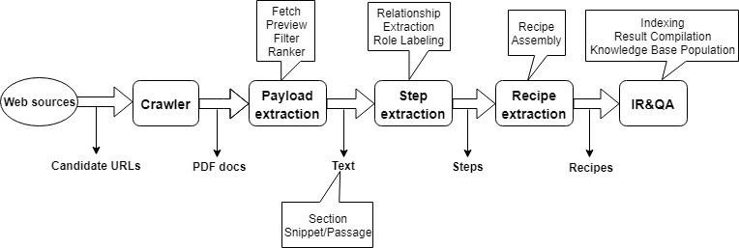
KSU KDD Wiki: nlp-information-extraction
•
William Hsu
https://www.kddresearch.org/page/nlp-information-extraction 📷
Yang, H., Aguirre, C. A., Hsu, W. (2022). PIEKM: ML-based Procedural Information Extraction and Knowledge Management System for Materials Science Literature. In Proceedings of the 2nd Conference of the Asia-Pacific Chapter of the Association for Computational Linguistics and the 12th International Joint Conference on Natural Language Processing: System Demonstrations (AACL-IJCNLP 2022), November 20-23, 2022, virtual conference.

William Hsu
Yang, H., Aguirre, C. A., Hsu, W. (2022). PIEKM: ML-based Procedural Information Extraction and Knowledge Management System for Materials Science Literature. In Proceedings of the 2nd Conference of the Asia-Pacific Chapter of the Association for Computational Linguistics and the 12th International …
Martin, C., Yang, H., & Hsu, W. (2022). KDDIE at SemEval-2022 Task 11: Using DeBERTa for Named Entity Recognition. In Proceedings of the 16th International Workshop on Semantic Evaluation (SemEval-2022), Seattle, USA, July 14-15, 2022.

William Hsu
Martin, C., Yang, H., & Hsu, W. (2022). KDDIE at SemEval-2022 Task 11: Using DeBERTa for Named Entity Recognition. In Proceedings of the 16th International Workshop on Semantic Evaluation (SemEval-2022), Seattle, USA, July 14-15, 2022.
Yang, H. & Hsu, W. (2022). Transformer-based Approach for Document Layout Understanding. In Proceedings of the 29th IEEE International Conference on Image Processing (ICIP 2022), Bordeaux, France, October 16-19, 2022.

William Hsu
Yang, H. & Hsu, W. (2022). Transformer-based Approach for Document Layout Understanding. In Proceedings of the 29th IEEE International Conference on Image Processing (ICIP 2022), Bordeaux, France, October 16-19, 2022.
Bose, A. & Hsu, W. H. (2023). Attention-Augmented Parametric Kernel Graph Neural Network (APKGNN) for Node Classification. In Proceedings of the 22nd International Conference on Machine Learning and Applications (ICMLA 2023), Jacksonville, FL, USA, to appear.

William Hsu9/9 5:00 PM
Edited
James Chapman9/9/2025 4:59 PM
you've mentioned a few ranked benchmarks in previous years. Does this group have any benchmarks we are targeting?
Original: https://catalog.ldc.upenn.edu/docs/LDC2008T19/new_york_times_annotated_corpus.pdf

- https://web.archive.org/web/20250701174542/https://paperswithcode.com/
- https://web.archive.org/web/20250512151129/https://paperswithcode.com/area/natural-language-process…
- https://web.archive.org/web/20241111050840/https://paperswithcode.com/task/topic-models
- https://web.archive.org/web/20221205190310/https://paperswithcode.com/sota/topic-models-on-nyt

•
Edited
William Hsu9/9/2025 5:00 PM
Original: https://catalog.ldc.upenn.edu/docs/LDC2008T19/new_york_times_annotated_corpus.pdf https://web.archive.org/web/20250701174542/https://paperswithcode.com/https://web.archive.org/web/20250512151129/https://paperswithcode.com/area/natural-language-process…https://web.archive.org/web/202…
Modern: NIST TAC - https://tac.nist.gov

https://tac.nist.gov/data/
•
William Hsu9/9 5:08 PM
Edited
William Hsu9/9/2025 5:03 PM
Modern: NIST TAC - https://tac.nist.gov https://tac.nist.gov/data/
Related work (from SPAR-KG domain):
Carpenter KA, Altman RB. Using GPT-3 to Build a Lexicon of Drugs of Abuse Synonyms for Social Media Pharmacovigilance. Biomolecules. 2023 Feb 18;13(2):387. doi: 10.3390/biom13020387. PMID: 36830756; PMCID: PMC9953178.

Using GPT-3 to Build a Lexicon of Drugs of Abuse Synonyms for Social Media Pharmacovigilance
Drug abuse is a serious problem in the United States, with over 90,000 drug overdose deaths nationally in 2020. A key step in combating drug abuse is detecting, monitoring, and characterizing its t...
doi.org

•
Edited
William Hsu9/9/2025 5:08 PM
Related work (from SPAR-KG domain): Carpenter KA, Altman RB. Using GPT-3 to Build a Lexicon of Drugs of Abuse Synonyms for Social Media Pharmacovigilance. Biomolecules. 2023 Feb 18;13(2):387. doi: 10.3390/biom13020387. PMID: 36830756; PMCID: PMC9953178. 📷
https://chatgpt.com/share/687bc5a6-b4e0-8002-87a3-0fb430f1b4e9

ChatGPT - OIE Research Test Bed
ChatGPT helps you get answers, find inspiration and be more productive. It is free to use and easy to try. Just ask and ChatGPT can help with writing, learning, brainstorming and more.
chatgpt.com

•
William Hsu9/9/2025 4:57 PM
https://www.kddresearch.org/page/nlp-information-extraction 📷
ICDAR (workshop): https://en.wikipedia.org/wiki/International_Conference_on_Document_Analysis_and_Recognition

Wikipedia Search
International Conference on Document Analysis and Recognition
The International Conference on Document Analysis and Recognition (ICDAR) is an international academic conference which is now held annually, each time
•
William Hsu9/9/2025 5:15 PM
ICDAR (workshop): https://en.wikipedia.org/wiki/International_Conference_on_Document_Analysis_and_Recognition 📎
https://www.icdar2025.com/program/list-of-workshops
•
William Hsu9/9/2025 5:17 PM
https://www.icdar2025.com/program/list-of-workshops
https://ws-dl.blogspot.com/2022/03/2022-03-06-trip-report-aaai-22-workshop.html
•
William Hsu9/9 5:37 PM
Edited
NELL Heng Ji

Google AI Overview
Heng Ji is a Professor of Computer Science at the University of Illinois Urbana-Champaign and a renowned expert in natural language processing (NLP). Her work is central to the fields of information extraction, knowledge base population, and the development of intelligent AI agents. [1, 2]

Connection to "Never-Ending Language Learning" (NELL)

Your query combines Heng Ji's name with "NELL," the Never-Ending Language Learner. This refers to her research on continuous, automated knowledge acquisition.
- WiNELL: In 2025, she and her team introduced WiNELL: Wikipedia Never-Ending Updating with LLM Agents. This framework was inspired by the vision of continuous learning from NELL and uses LLM-based agents to automatically and reliably update Wikipedia articles. The system is designed to mimic human editors by aggregating online information and suggesting factual edits for review.
- Keynote Speech: At the SEMANTiCS 2025 conference, she delivered a keynote address titled "From NELL to WINELL: the journey of never-ending knowledge continues," where she detailed how LLM agents can keep knowledge fresh, structured, and fair. [2, 3, 4]
Research and career highlights
- Research interests: Her work focuses on multimedia multilingual information extraction, knowledge-enhanced large language models, and vision-language models. She is the head of the BLENDER Lab at the University of Illinois Urbana-Champaign, which focuses on cross-lingual, cross-document, and cross-media information extraction.
- Collaborations: Ji is the Founding Director of the Amazon-Illinois Center on AI for Interactive Conversational Experiences (AICE) and serves as an Amazon Scholar. Her research is supported by a variety of government and industry entities, including Amazon, Google, DARPA, and the National Science Foundation (NSF).
- Notable achievements:
  - Coordinated the NIST TAC Knowledge Base Population task for over a decade.
  - Named "one of AI's 10 to watch" by IEEE Intelligent Systems in 2013.
  - Named to the "Women Leaders of Conversational AI" list in 2023.
  - Authored a highly cited body of work on topics such as named entity recognition, relation extraction, and event extraction. [1, 5, 6, 7, 8, 9]

AI responses may include mistakes.
[1] https://siebelschool.illinois.edu/about/people/faculty/hengji
[2] https://chatpaper.com/paper/174030
[3] https://x.com/hengjinlp/status/1963576366688833876
[4] https://openreview.net/forum?id=Eoz0rvvkux
[5] https://en.wikipedia.org/wiki/Heng_Ji
[6] https://asks.grainger.illinois.edu/heng-ji
[7] https://scholar.google.com/citations?user=z7GCqT4AAAAJ&hl=en
[8] https://en.wikipedia.org/wiki/Heng_Ji
[9] https://x.com/hengjinlp

Heng Ji | Siebel School of Computing and Data Science | Illinois
Heng Ji
siebelschool.illinois.edu

•
William Hsu9/9/2025 5:37 PM
NELL Heng Ji Google AI Overview Heng Ji is a Professor of Computer Science at the University of Illinois Urbana-Champaign and a renowned expert in natural language processing (NLP). Her work is central to the fields of information extraction, knowledge base population, and the development of…
https://arxiv.org/abs/2508.03728

WINELL: Wikipedia Never-Ending Updating with LLM Agents
Wikipedia, a vast and continuously consulted knowledge base, faces significant challenges in maintaining up-to-date content due to its reliance on manual human editors. Inspired by the vision of...
arxiv.org


1 Like reaction.
•
Syed Ahsan Masud Zaidi9/9 5:41 PM
https://cs-kdd-nl-llm.kdd.cs.ksu.edu/

1 Like reaction with medium light skin tone.
•
William Hsu9/9 5:42 PM
Syed Ahsan Masud Zaidi9/9/2025 5:41 PM
https://cs-kdd-nl-llm.kdd.cs.ksu.edu/
Our LLM service page: https://kstate.atlassian.net/wiki/x/ngBi2

Log in with Atlassian account
Log in to Jira, Confluence, and all other Atlassian Cloud products here. Not an Atlassian user? Sign up for free.
kstate.atlassian.net

• Recording has stopped. Saving recording…
9/9 5:44 PM Recording has stopped. Saving recording…
• Meeting ended: at 9/9 5:44 PM after 1 hour 36 minutes 59 seconds, Open IE monthly coordination meeting , Tuesday, September 9, 2025 4:00 PM - 5:00 PM, link to view recap, This meeting contains 1 recording, 2 files, Press Enter to view more
9/9 5:44 PM Meeting ended: 1h 36m 59s
Open IE monthly coordination meetingTuesday, September 9, 2025 4:00 PM - 5:00 PM
View recap
Content
Transcript
Agenda and notes
1h 36m 52s
Expires in 24 days
• Recording has been saved to this channel's SharePoint site.
9/9 5:49 PM Recording has been saved to this channel's SharePoint site.

